# Research Plan on Quality Factor

$$B∝\frac{{\left({m_{S}^{*}}/{m_{c}^{*}}\right)}^{3/2}}{v_{s}}$$

* $m_{S}^{*}$ is the Seebeck effective mass
* $m_{c}^{*}$ is the conductivity effective mass
* $v_{s}$ is the speed of sound

The goal is to maximize the quality factor $B$.

## Seebeck effective mass

### Method 1. Approximation equations

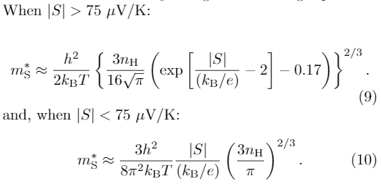

Here $n_{H}$ is the Hall carrier concentration. How to get it?

### Method 2. Pisarenko plot

Directly obtain the Seebeck effective mass from a set of data points. How?

### Method 3. Pymatgen + BoltzTraP?

There is a function called get_seebeck_eff_mass() in pymatgen.

<http://pymatgen.org/pymatgen.electronic_structure.boltztrap.html>

Can we take advantage of pymatgen in this TE study?

## Conductivity effective mass

### Method 1. Hall mobility measurement

This can tell us the effective carrier concentration and effective mobility as a function of temperature.

There are 3 papers in Starrydata2 with keywords “Hall mobility” in the title. All old.

Assuming we have the data, how to get $m_{c}^{*}$ from these measurements?

### Method 2. Electrical conductivity measurement

There are many papers in Starrydata2 with electrical conductivity vs. temperature plots, e.g., <https://www.starrydata2.org/paperlist/data/599a9785b036dfb17bdd31f9/GeneralDB> (need to log in)

How to calculate $m_{c}^{*}$ from here?

### Method 3. Derive from band structure, transverse & longitudinal effective mass ?

<https://nanohub.org/groups/ece656_f13/File:Notes_on_Effective_Masses.pdf>

## Speed of sound

Get it from effective elastic constants and density.

We can get elastic tensor from MP. Need to confirm what compounds from the effective mass calculations.